TN&P Section Awards for Engineering Faculty a will be presented at
20th ISTE TN&P Section Annual Convention for Engineering Faculty Members – 2017
Mahendra Engineering College, Salem, on 26th March 2018.
Sl. No | Name of the Award | Name and Address of the Awardees’
1 | ISTE-PERIYAR AWARD FOR THE BEST ENGG COLLEGE TEACHER-2017  for the contribution to technical education by innovative teaching and research. | 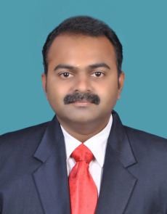 | Dr. J.Karthikeyan  Professor  SSM Institute of Engineering & Technology,  Dindigul - 624002
1 |  | 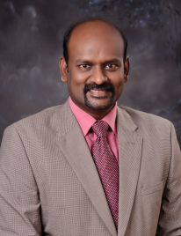 | Prof. S.Andrews  Professor  Mahendra Engineering College  Mallasamudram - 637503
2 | BEST ISTE CHAPTER CHAIRMAN AWARD FOR ENGINEERING COLLEGES - 2017  for organizing more number of programmes to the benefit of faculty members | 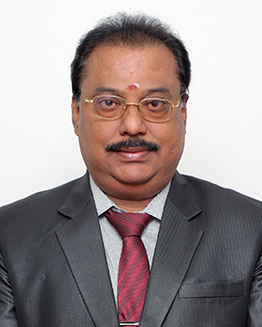 | Dr. S.R.R.Senthil Kumar  The Principal  SONA College of Technology,  Salem - 636 005
3 | BEST ISTE CHAPTER SECRETARY AWARD  FOR ENGINEERING COLLEGES - 2017  for organizing more number of programmes to the benefit of faculty members | 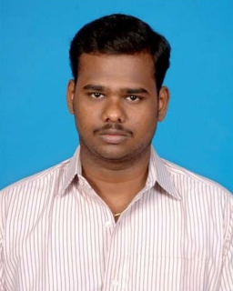 | Prof. N.Arun Kumar  Professor  Mahendra Institute of Technology  Mallasamudram - 637503
4 | BEST ISTE STUDENTS CHAPTER FACULTY ADVISOR AWARD 2017  FOR ENGINEERING COLLEGE  for guiding to arrange more number of programmes to the benefit of student members. | 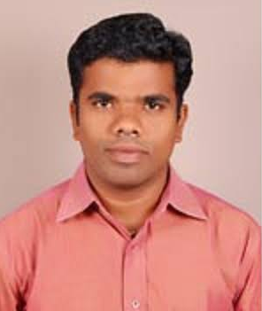 | Prof. B.Venkatesan  Associate Professor  Paavai Engineering College  Pachal – 637 018
4 |  |  | Prof. T.Krishnamoorthi  Asst. Professor in Mech. Engg.  Nandha College of Technology  Erode - 638 052
5 | ISTE TN Section Appreciation Award  for mobilizing Maximum Students Membership (01/06/2016 to 31/05/2017) | The Principal  SNS College of Technology,  Coimbatore-641 035  principal@snsct.org, 9443791005
5 |  | The Principal  Sri Sairam Engineering College,  Chennai – 600 017  sairam@sairam.edu.in, principal@sairam.edu.in  9677065557
5 |  | The Principal  Bannari Amman Institute of Technology, Sathyamangalam - 638 401  stayahead@bitsathy.ac.in, principal@bitsathy.ac.in  9842217170
6 | ISTE TN Section Appreciation Award  For mobilizing Maximum Life Membership (01/06/2016 to 31/05/2017) | The Principal  Valliammal Engineering College,  Kattankulathur,  Chennai - 603 203
6 |  | The Principal  P.A. College of Engineering and Technology,  Pollachi – 642 002  9443584648, pacollege@yahoo.com,
6 |  | The Principal  Bannari Amman Institute of Technology, Sathyamangalam - 638 401  stayahead@bitsathy.ac.in, principal@bitsathy.ac.in  9842217170
7 | ISTE TN Section Appreciation Award  for Successful Conduction of  19th ISTE State Annual Convention for Engineering Faculty Members – 2016  2nd & 3rd December 2016 | Dr. K.Porkumaran  Principal  Dr. N.G.P. Institute of Technology,  Coimbatore-641 048
8 | ISTE TN Section Appreciation Award  for Successful Conduction of  15th ISTE TN section Annual Convention for Engineering Students – 2016  14th February, 2017 | Dr. N.Mahendran  Principal  PSNA College of Engineering and Technology,  Dindigul – 624 622
9 | ISTE TN Section Appreciation Award  for Successful Conduction of  1st ISTE TN section Annual Convention for Architecture, Pharmacy, MBA and MCA College Students – 2018  24th February, 2018 | The Principals  Excel College of Pharmacy, Excel College of Architecture and Excel Business School  Pallakkapalyam,  Komarapalayam - 638183
10 | ISTE TN Section Appreciation Award  for Successful Conduction of  6th ISTE TN section Annual Convention for Polytechnic College Students – 2017  19th January, 2018 | The Principal  Thiagarajar Polytechnic College  Salem - 636005
11 | ISTE TN Section Appreciation Award  for Successful Conduction of  4th ISTE TN Section Annual Convention for Polytechnic College Faculty Members – 2017  30th December, 2016 | The Principal  Thiagarajar Polytechnic College  Salem - 636005

